**INTRODUCTION TO DATA MANAGEMENT**

**PROJECT REPORT**

(Project Semester January-April 2025)

***(U.S. FOOD IMPORTS)***

Submitted by: Varshitha

Registration No: 12325869

Section: K23GS

Course Code: **INT217**

Under the Guidance of

**Baljinder Kaur (27952)**

**Discipline of CSE/IT**

**School of Computer Science**

**Lovely Professional University, Phagwara**

**CERTIFICATE**

This is to certify that Varshitha bearing Registration no. 12325869 has completed INT 217 project titled, **“U.S. FOOD IMPORTS”** under my guidance and supervision. To the best of my knowledge, the present work is the result of his/her original development, effort and study.

**Signature and Name of the Supervisor**

**Designation of the Supervisor**

**School of …………………………………………….**

Lovely Professional University

Phagwara, Punjab.

Date:

**DECLARATION**

I Varshitha, student of Computer Science (Program name) under CSE/IT Discipline at, Lovely Professional University, Punjab, hereby declare that all the information furnished in this project report is based on my own intensive work and is genuine.

Date: Signature: Registration No.12325869 Varshitha

1. **Introduction**

The U.S. Food Imports data product is an annually published statistical summary of the value and volume of food imports coming into the United States.

U.S. consumers demand variety, quality, and convenience in the foods they consume. As U.S. consumers have become wealthier and more ethnically diverse, their food basket reflects a growing share of tropical products, spices, and imported gourmet products. Seasonal and climatic factors drive U.S. food imports of popular types of fruits, vegetables—and tropical products, such as cocoa and coffee. In addition, a growing share of U.S. imports can be attributed to intra-industry trade, whereby agricultural-processing industries based in the United States carry out certain processing steps offshore and import products at different levels of processing from their subsidiaries in foreign markets.

This data set provides import values of edible products (food and beverages) entering U.S. ports and the products’ origin of shipment. Data are from the U.S. Department of Commerce, Bureau of the Census. Food and beverage import values are compiled by calendar year into food groups, corresponding to major commodities or level of processing. The Harmonized System (HS) codes and the corresponding commodities and food products are detailed in the data product file. At least 20 years of annual data are included, enabling users to track long-term growth patterns.

1. **Source of Dataset**

Link: <https://www.ers.usda.gov/data-products/us-food-imports>

1. **Dataset Preprocessing**

The dataset contains 11,551 rows and 8 columns. Preprocessing steps included:

- Column Renaming.

- Verifying the data types for numerical and categorical columns.

- Handling any missing values (though none were found).

- Grouped similar food items under broader categories (e.g., grouping "Cheese", "Milk powder" under "Dairy").

**4.Analysis on Dataset (for each objective)**

**i. General Description**

This dataset provides a comprehensive view of India’s food import patterns, allowing for analysis of trends over time, key commodity dependencies, and country-wise import contributions. It has been cleaned and pre-processed for easier analysis, making it ideal for trade analysis, forecasting, and policy planning.

**ii. Specific Requirements**

The main objectives of this analysis are:

Understand Import Trends Over Time.

Identify Major Imported Food Commodities

Analyze Country-Wise Import Patterns.

Evaluate Category-Wise Contribution.

**iii. Analysis Results**

**Rising Import Trend:**  
Food import values have shown a consistent upward trend from 1999 to recent years, reflecting increasing demand and consumption.

**Top Imported Commodities:**  
Commodities like **Cereals**, **Dairy Products**, and **Edible Fruits & Vegetables** dominate the import market in terms of value.

**Major Import Source Countries:**  
Countries such as the **United States**, **China**, and **Australia** are among the leading exporters of food products to India.

**Category Insights:**  
The **'Edible Fruits & Nuts'** and **'Cereal Preparations'** categories show the highest year-over-year growth in import value.

**Trade Dependency:**  
India shows high dependency on a small group of countries and commodity types, which could pose a risk in terms of supply chain stability.

**Fluctuations & Anomalies:**  
Certain years experienced sudden spikes or drops in import values, possibly due to policy changes, global market conditions, or natural events.

**Opportunities for Local Production:**  
High import values in specific commodities highlight the potential for expanding domestic production to reduce foreign dependency.

**iv. Visualization**

Visualizations (charts/graphs) included:

Total Import Value by Country -clustered chart.

Yearly Import Trend -Line Chart.

Import Share by Commodity-pie chart.

Category-wise 2023 Trends of India bar chart.

Top 5 Countries for a Specific Commodity-Donut.

**5. Conclusion**

The *Cleaned food Imports* dataset highlights a consistent rise in food imports, with key dependencies on specific commodities and countries. This trend points to growing domestic demand and limited local production. The analysis suggests potential risks due to trade concentration and offers opportunities for boosting local agriculture to enhance food security and reduce reliance on external sources.

**6. Future Scope**

Further analysis can include:

Country-Wise Trade Analysis.

Commodity-Specific Trends.

Time Series Forecasting.

Machine Learning Insights.

**7. References**

Dataset: Cleaned_FoodImport.xlsx got it from the usda.gov

**Links**

LinkedIn:

<https://www.linkedin.com/feed/update/urn:li:activity:7317203334732419072/>

Dash Board:

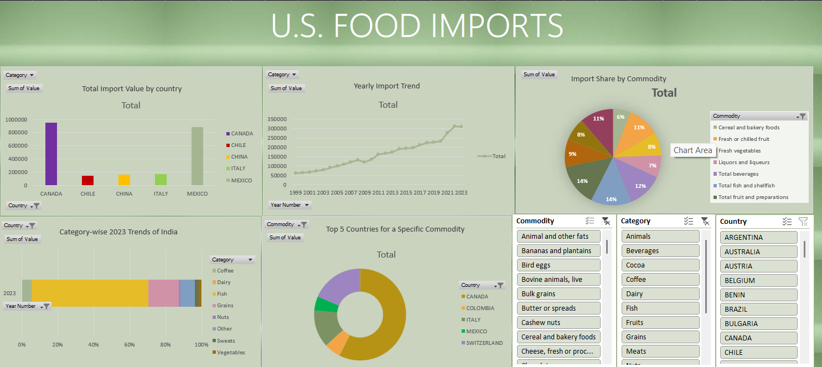

Sample Data Set:

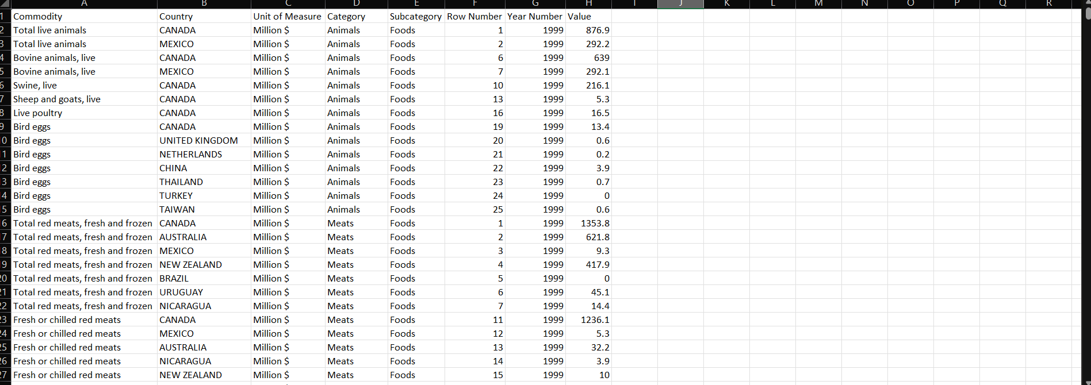

1.Total Import Value by Country

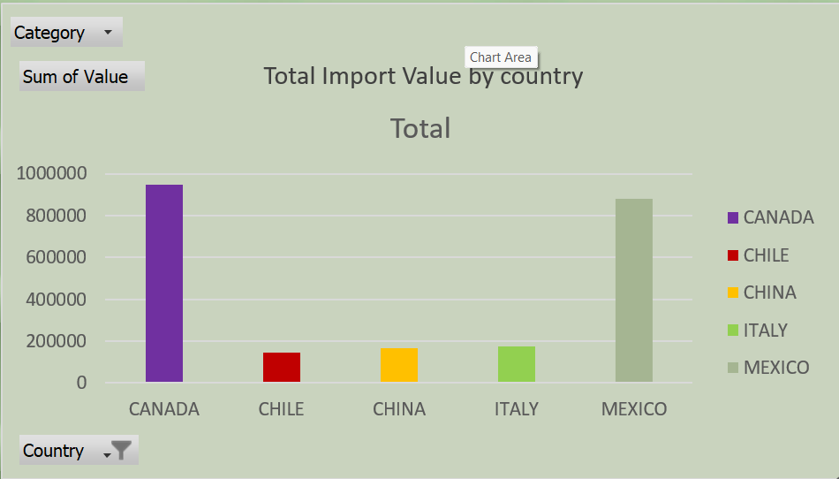

2.Yearly Import Trend

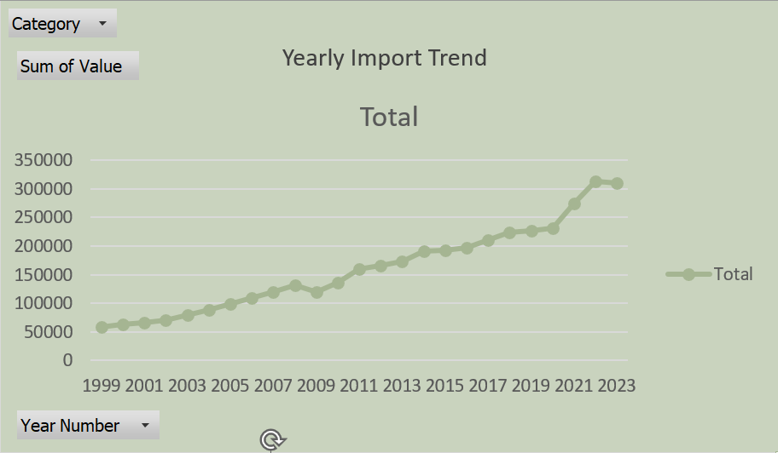

Import Share by Commodity:

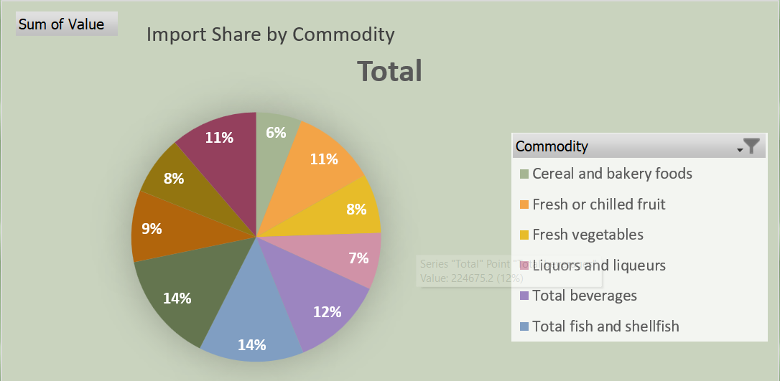

Category-Wise Yearly Trends:

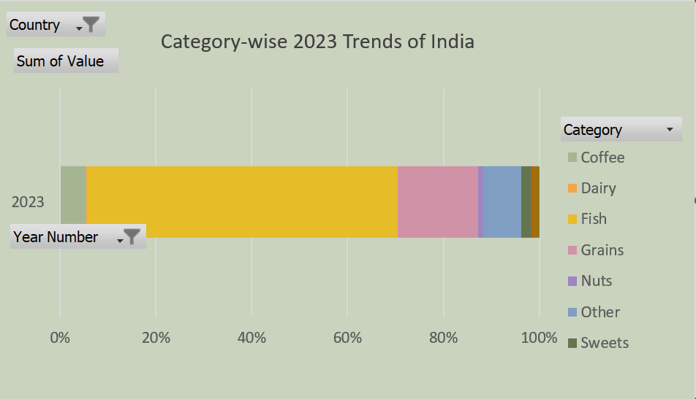

Top 5 Countries for a Specific Commodity:

